**DEEP LEARNING BASED CAT BREED CLASSIFICATION**

**Objective:** The main objective of this to classify the images of cat breeds using the Convolution Neural Network (CNN) of deep learning.

**Software & Hardware Requirements:**

# **H/W Configuration:**

# Processor : I3/Intel Processor

* Hard Disk : 160GB
* RAM : 8Gb

**S/W Configuration:**

* Operating System : Windows 7/8/10 .
* Server side Script : HTML, CSS & JS.
* IDE : Pycharm.
* Libraries Used : Numpy, IO, OS, Flask, keras.
* Technology : Python 3.6+.

**Project Flow:**

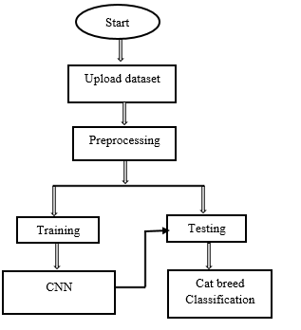

**Flow of Proposed method**